Rose-Hulman Mobile Student Lookup

User Manual

Version 1.0

Last Modified:

April 26, 2012

Table of Contents

Introduction 3

Purpose 3

Setting up My iPhone 3

1. Download iTunes to My Computer 3

2. Create an iTunes App Store Account 3

3. Setting up your iPhone 4

4. Installing Rose-Hulman Mobile Student Look-up 4

Mobile Student Lookup Setup 4

Kerberos Credentials 4

Changing Kerberos Credentials 4

Features 5

Searching 5

By Username: 5

Results for Username Search 5

By Room: 5

Results for Room Search 5

Results for Course Search: 5

Viewing 6

Usernames 6

Course 6

Favorites 6

Adding to Favorites: 6

Shortcut to Favorites: 6

FAQ 7

Appendix 8

# Introduction

The Mobile Student Lookup allows Rose-Hulman students to access their schedules on their iPhone, iTouch or iPad. The application also allows students to lookup faculty, staff, classrooms, and offices as well as having access do their friends schedule in one simple location.

# Purpose

* More streamlined process to checking your schedule
* Easier to navigate schedules of others
* Intuitive for all user levels
* Easier to read

# Setting up My iPhone

Rose-Hulman Mobile Student Look-up is an application that will soon be available for purchase from the *App Store* on your iPhone. To access the *App Store* you will need to download the Apple iTunes program to your computer and create an *App Store* account.

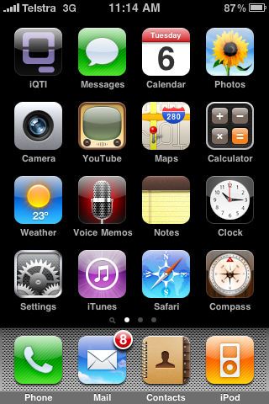

## Download iTunes to My Computer

* + Go to [http://www.apple.com/iTunes/](http://www.apple.com/itunes/)
  + Click “**iTunes**”
  + Click “**Download Now**” and Follow Prompts

## Create an iTunes App Store Account

* + Open iTunes on your Computer
  + Click “**Store**” dropdown
  + Select “**Create Account**”

***Please note you may be asked for a Credit Card Number for future purchases but this application will not be charged to your account.***

* + Make note of Username and Password

***Rose-Hulman Mobile Student Look-up is a free application.***

## Setting up your iPhone

* + On your device, Open ***AppStore***
  + Search for “**Rose-Hulman Mobile Student Look-up**”
  + Click “**Free**” then Click “**Install**”

## Installing Rose-Hulman Mobile Student Look-up

* + Click “ **Use Existing Apple ID**”
  + Enter Your Username and Password
  + Enter your iTunes Password
  + Click “**OK**”
  + Enjoy the Application

# Mobile Student Lookup Setup

## Kerberos Credentials

*See Figure 1 in Appendix.*

Once the Application is installed click and run Student Look-up application.

1. Enter your Rose-Hulman Username and Password

## Changing Kerberos Credentials

*See Figure 1 in Appendix.*

* 1. Run Application
  2. Click “**Settings**” on the Bottom of the screen
  3. Change necessary credentials

# Features

## Searching

### By Username:

*See Figure 2 in Appendix.*

1. Click “**Search**” on the Bottom
2. Select “**Username**” and the **Term** and **Year** you are searching.
3. Type the **username** (partial usernames are okay) and click “**Search**”

### Results for Username Search

*See Figure 3 in Appendix.*

1. Once you complete your search described above
2. If not an exact match, select on desired result and
3. Information will then be displayed for that Username
4. Once you search for an individual, you will be able to View Schedule* or Add to Favorite**

\**For more information about View Schedule see View Schedule Section Below*

*\*\*For more information about Add to Favorite see Add to Favorite Section Below*

### By Room:

*See Figure 4 in Appendix.*

1. Click “**Search**” on the Bottom
2. Select “**Room**” and the **Term** and **Year** you are searching for
3. Type the **Room Number** (exact match only) and click “**Search**” (i.e. F217)

### Results for Room Search

1. Once you complete your search described above
2. Information will be displayed for that Room Number

**By Course:***See Figure 6 in Appendix.*

1. Click “**Search**” on the Bottom
2. Select “**Course**” and the **Term** and **Year** you are searching for
3. Type the **Course ID** (partial courses are okay) and click “**Search**” (i.e . CSSE375)

### Results for Course Search:

*See Figure 7 in Appendix.*

1. Once you complete your search described above
2. If not an exact match, select on desired result
3. Information will then be displayed for that Course

## Viewing

### Usernames

*See Figure 8 in Appendix*

1. Once you search for an individual, you will be able to view the schedule
2. Select “**View** **Schedule**”
3. Slide finger across screen to see different days*

\**See Figure 9 in Appendix.*

### Course

*See Figure 10 in Appendix*

1. Once you search for an Course, you will be able to view the student roster
2. Select View Roster *

\**See Figure 11 in Appendix.*

## Favorites

This allows you to store an individual’s schedule for quick reference. This is particularly handy with group projects.

### Adding to Favorites:

*See Figure 12 in Appendix.*

1. Search for the Individual’s username (See Searching)
2. Click on the desired username
3. Click the option to add to Favorites

### Shortcut to Favorites:

*See Figure 13 in Appendix.*

1. Run the Application
2. Click “ **Favorites**” on the bottom of the screen

## FAQ

Q: Does your application store my Username and Password?

A: Yes, the application stores your username and password locally on your device. It uses the same security measures as storing your email password and username, which cannot be read by any application on your device.

Q: Does your application keep a copy of my schedule?

A: No, it is retrieved only when you search for it.

Q: Is your application only for Rose-Hulman Students?

A: No, it is available to all Rose-Hulman personnel.

Q: Is the application free?

A: Yes!

Q: How do you have access to all of this information?

A: You already have access to all of this information yourself via the Registrar’s Schedule Lookup page. This application uses the same type of lookup, but it is displayed in an efficient manner for iOS devices.

# Appendix

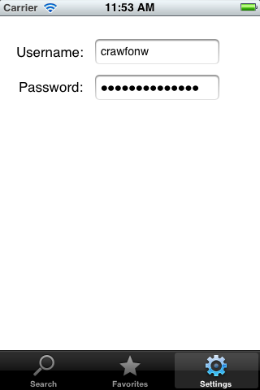  
**Figure 1 Kerberos Sign In and Changing Credentials**

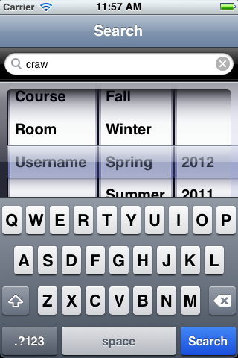

Figure 2 Search Username

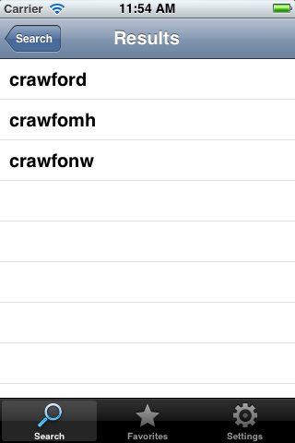

**Figure 3 Username Search Results**

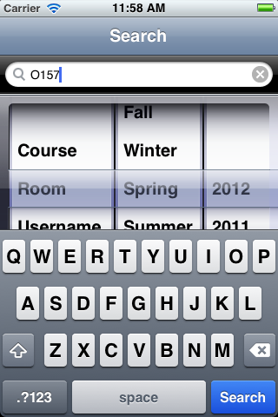

**Figure 4 Search Room Number**

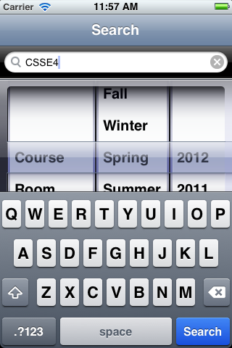

**Figure 6 Course Search**

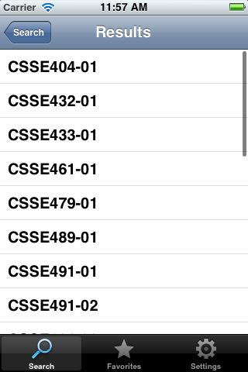

**Figure 7 Course Search Results**

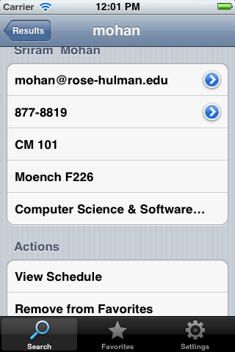

**Figure 8 User Information**

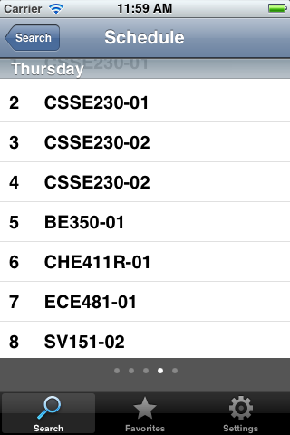

**Figure 9 Class Schedule**

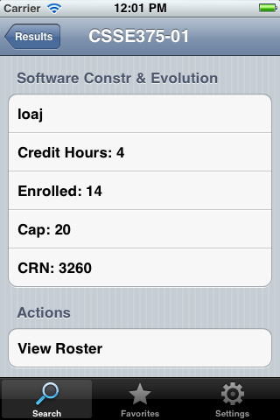

**Figure 10 Class Information**

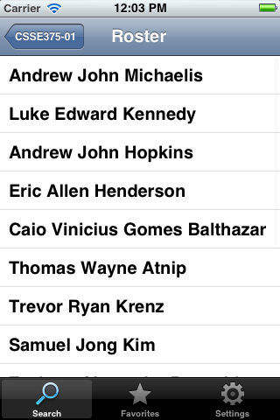

**Figure 11 Class Roster**

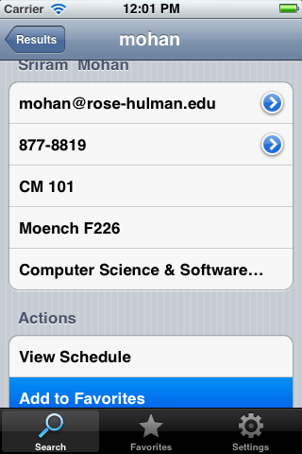

**Figure 12 Add to Favorites Button**

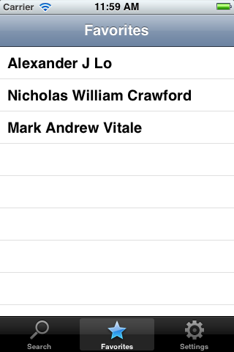

**Figure 13 List of Current Favorites**